GPON PRE DESIGN

We Need to capture each and every station values from the Katapult to the Auto-cad file. Please provide the Information in CAD of Property number, street names , Drops , Driveway as per Katapult if it is not there. Open your file in the Katapult i.e., 704212260_2CA1 and keep lock whenever you open the File.

Key Points:

NOTE 1:

- Provide the Symbols for Water Valve, Fire Hydrant, Transformer, Bush or Tree, PED CAT Street Light, CA BEND, WATER METER, ETC. check in the'OBSTACLE Type' in katapult and provide the Symbols in the CAD. These Symbols will be at LEGEND. For remaining, which are not there in LEGEND just provide the Station Value and Text of the Obstacle Type for it. For, Tree and Bush same symbol.

GPON POST DESIGN

* Need to verify all the premises
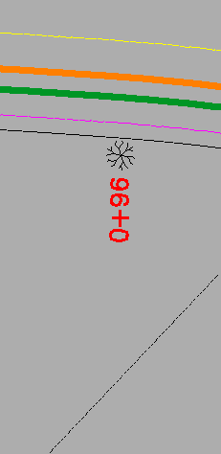
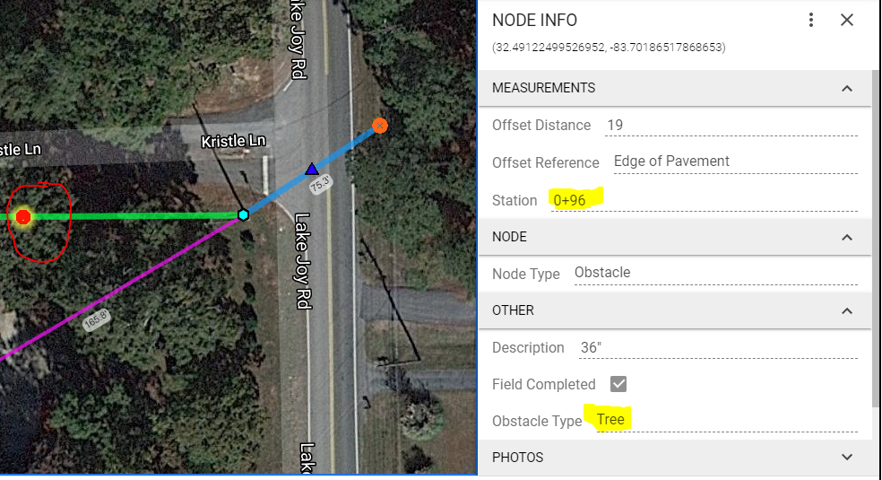

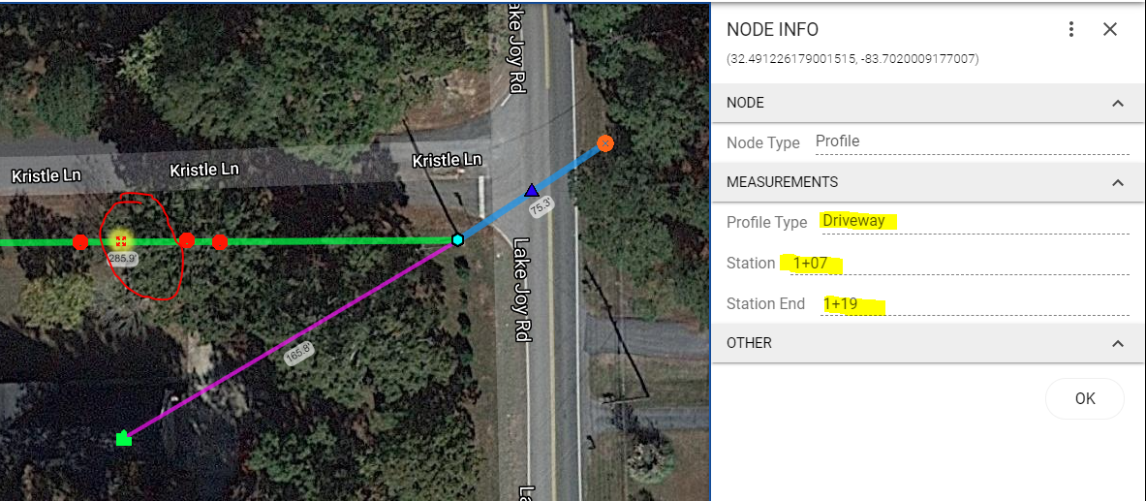

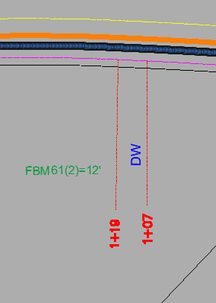

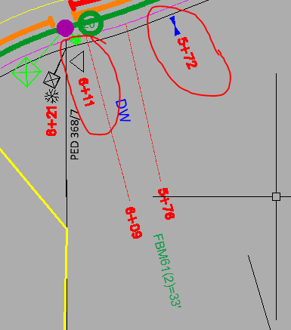
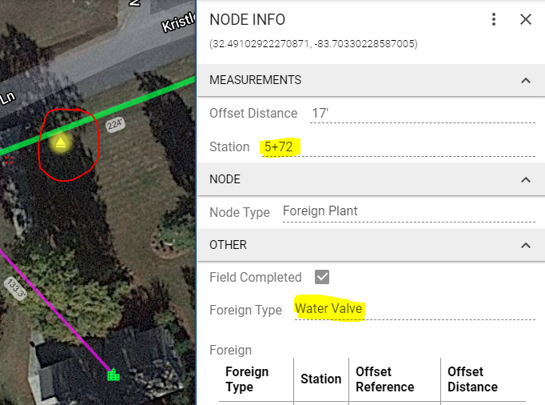

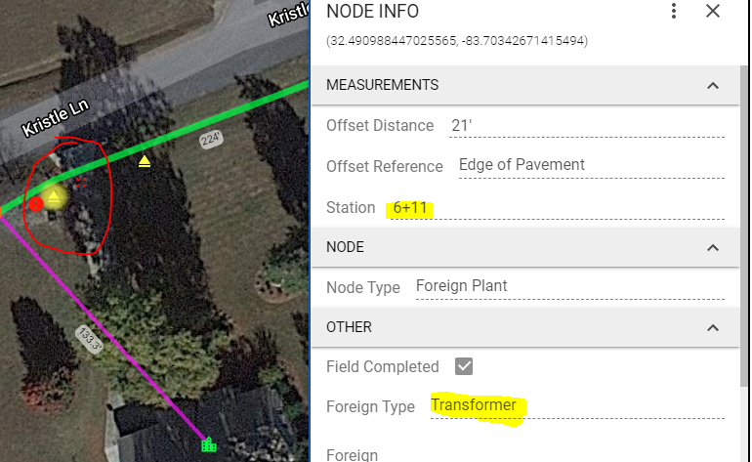

NOTE: 02

Provide the Offset only at the Pedstral only i.e.,7' OFFSET PED

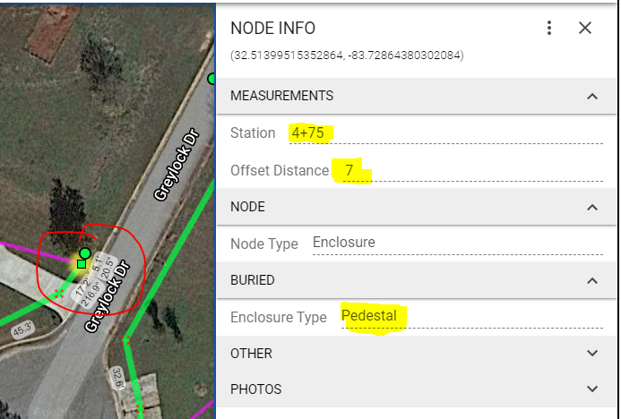

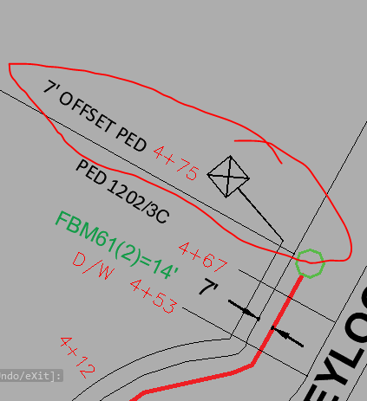

NOTE 3:

- Please delete the two DW text in Autocad and mention only DW in the Place of the CONC DW. And mention values accordingly.
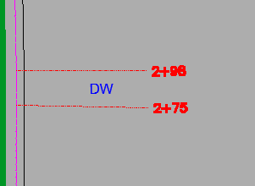
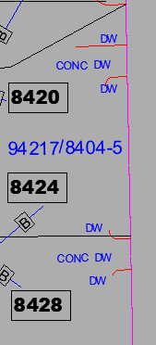

NOTE 4:

- After Completion of providing all Station Values, at the Middle of the Driveway D/W , provide the difference of both station values at the Driveway i.e., FBM61(2)=23' . FBM61(2)=** is similar for every D/W.

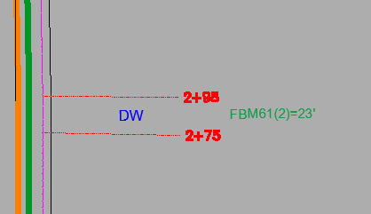

NOTE 5:

- Please provide all the values as per TEXT ALIGNMENT. Adjust or Scale your Text as per your Area as low as possible. Make sure we should keep the Station value exact location as per katapult in the Drawing File. NO OVERLAPS SHOULD BE PRESENT IN THE DRAWING FILE.

